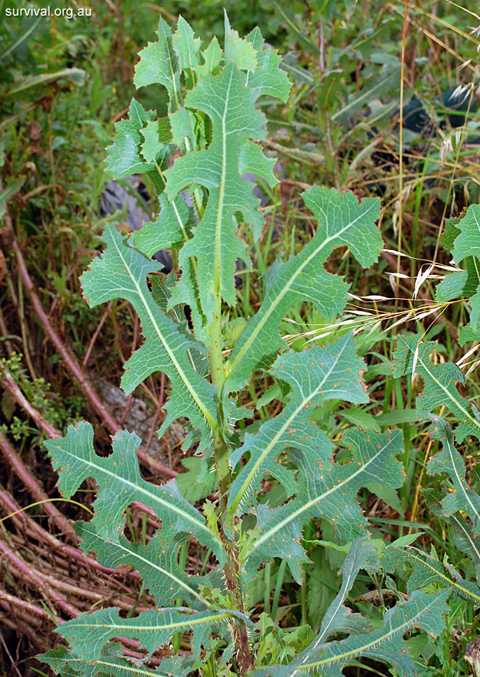 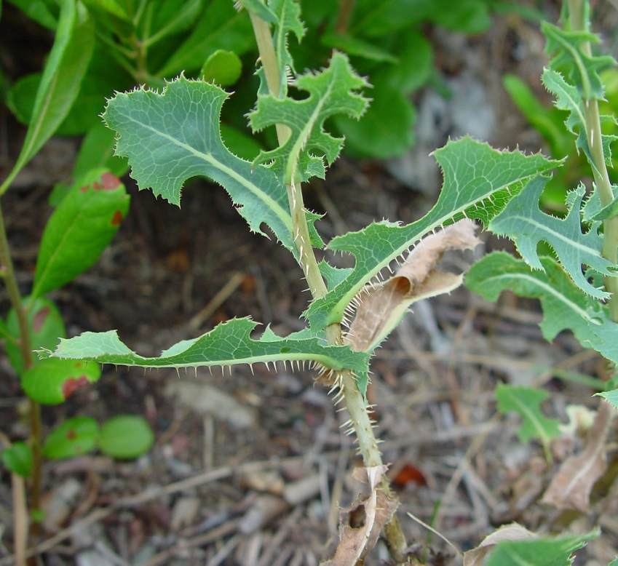

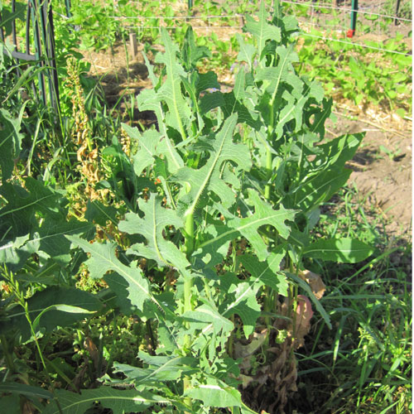 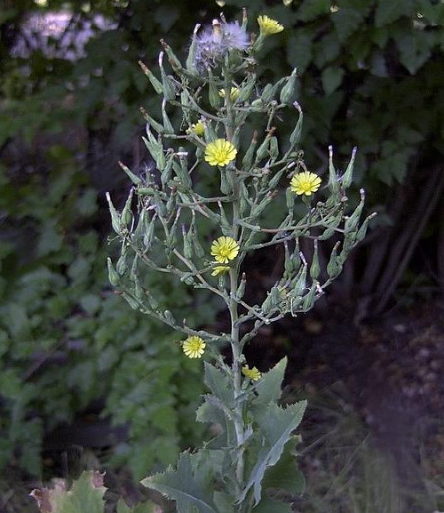

Wild lettuce, *Lactuca*

Pick it before it flowers!

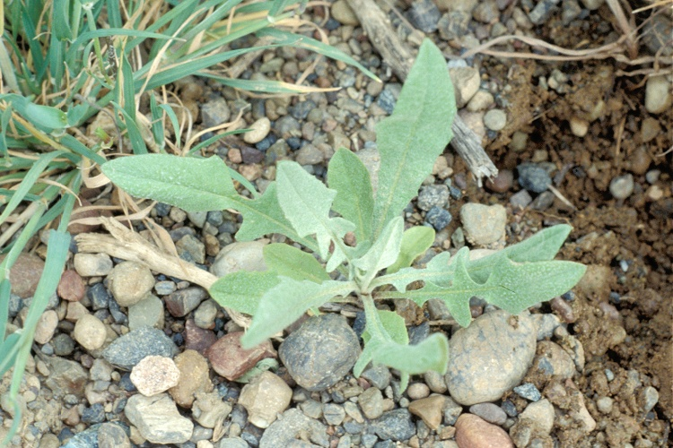 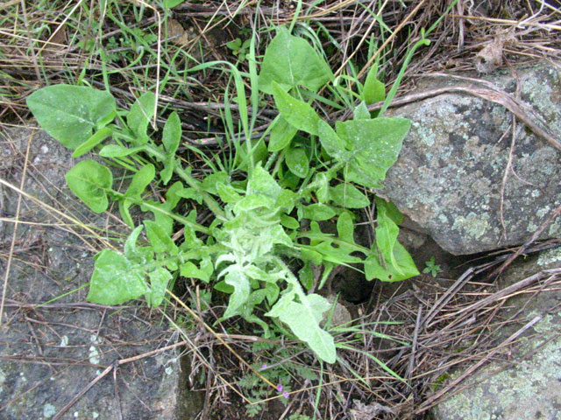

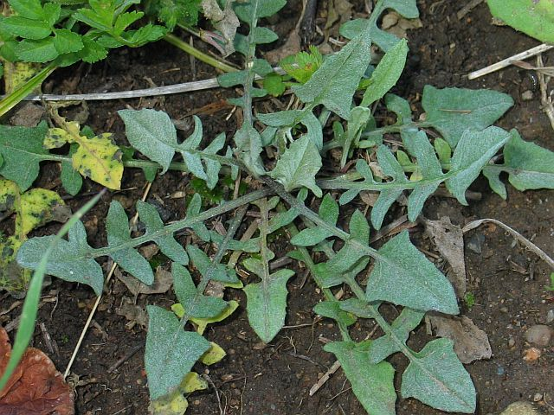 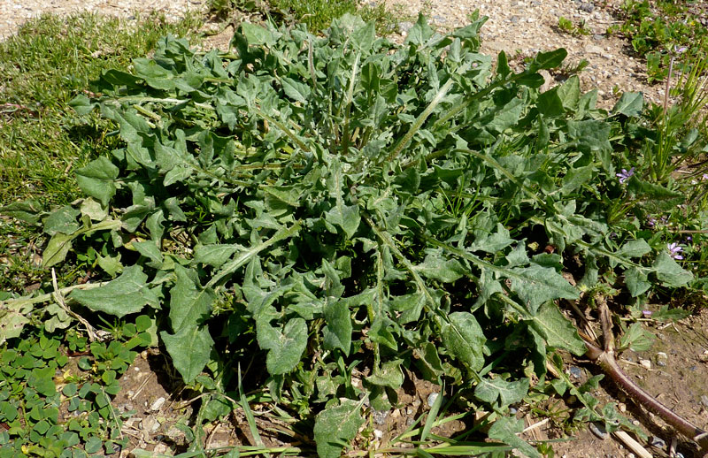

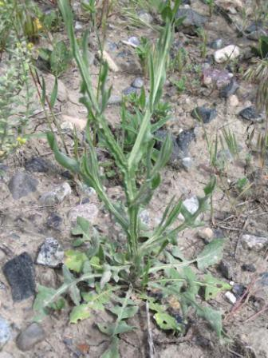 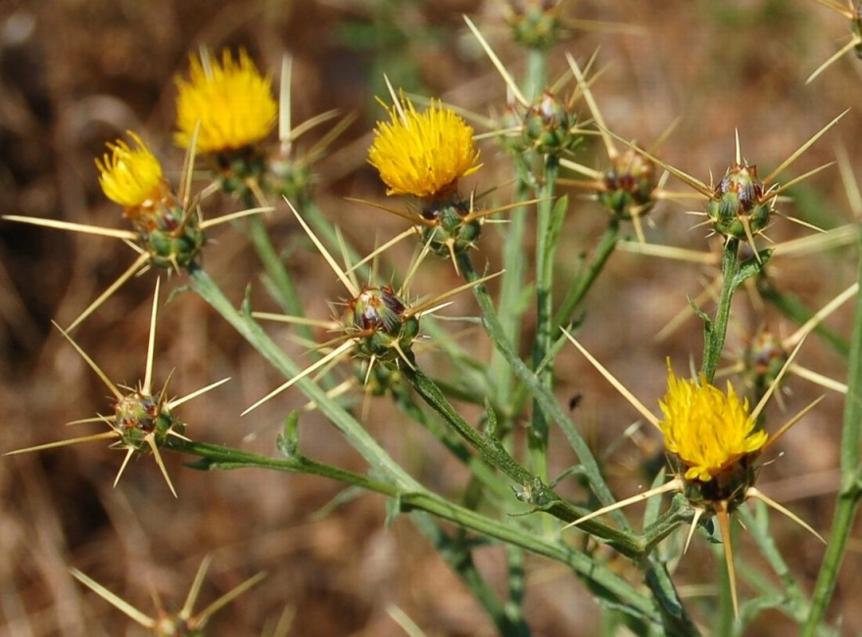

Yellow starthistle, *Centaurea solstitialis*

Note: tiny starthistle rosettes sometimes grow in extremely thick patches; don’t bother picking every plant there. Leave all starthistle in the “CESO” plots which are indicated on the sheet. Once they start growing a stem they are very difficult to pull, clipping them at the soil surface is fine

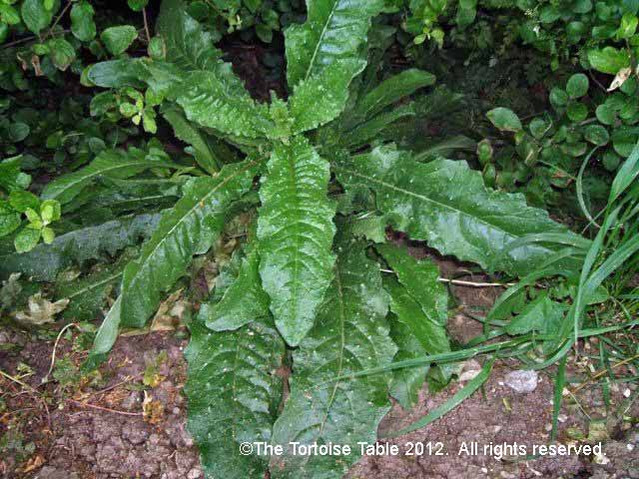 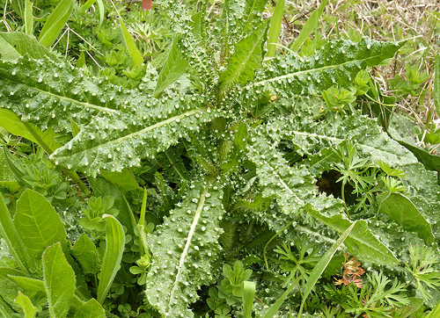

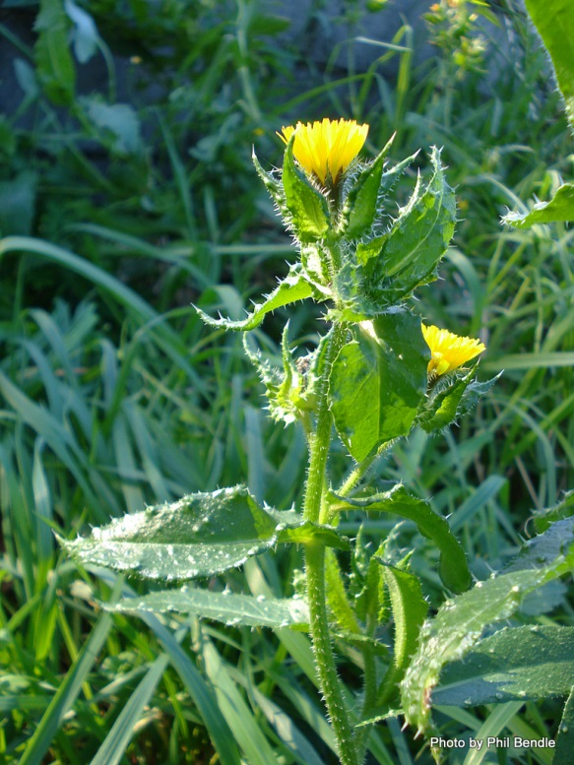 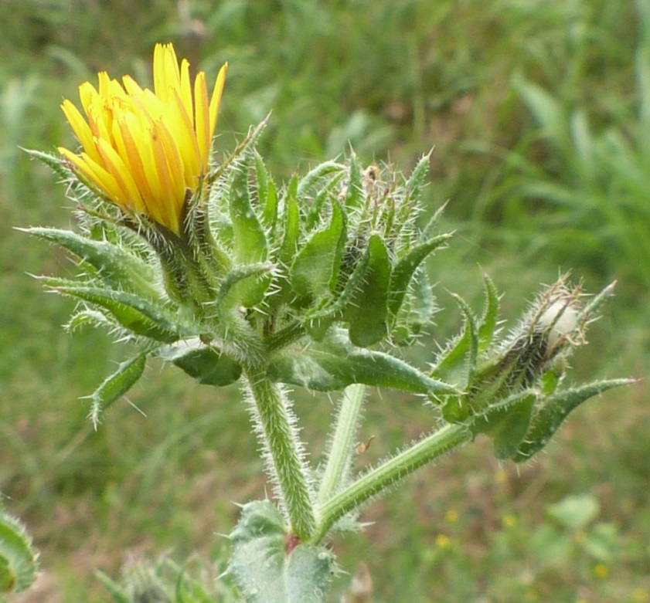

Bristly oxtongue, *Picris echioides*

OUCH! Warty-looking spines deliver a painful sting! Use gloves!! Don’t let them flower!!

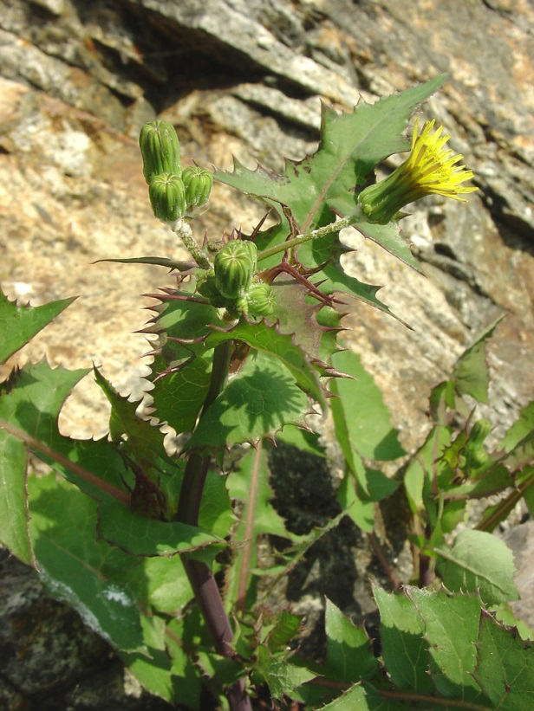

Sowthistles, *Sonchus*

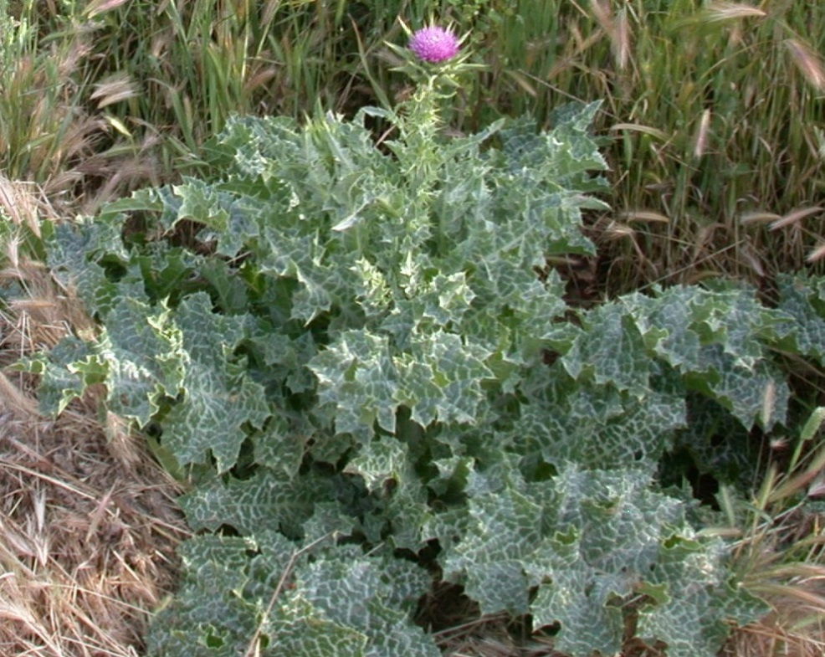

Milk thistle, *Silybum marianum*

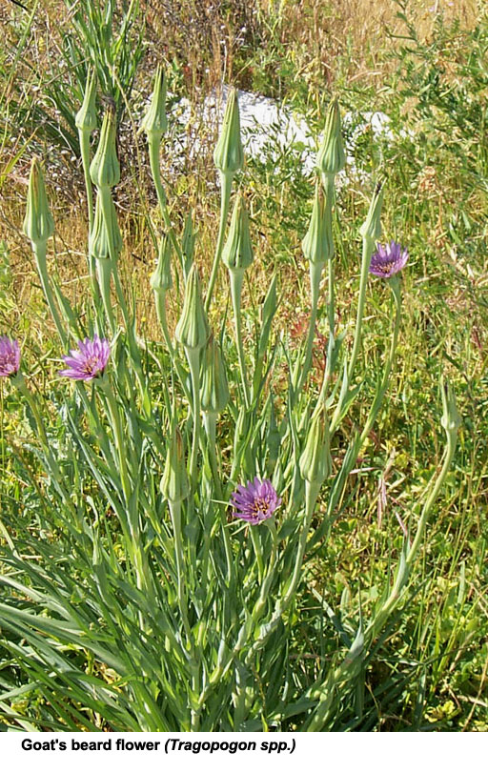

Salsify or Goat’s-beard, *Tragopogon*

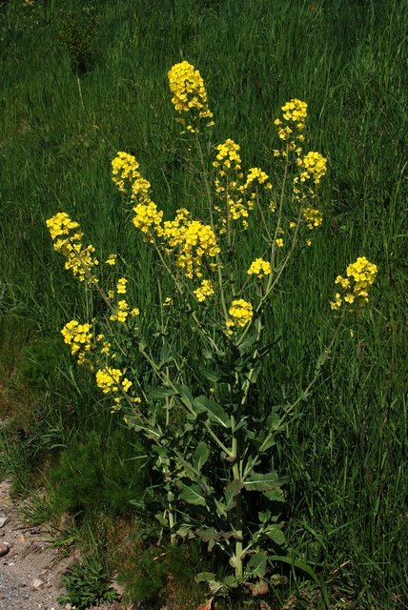

Wild mustard, *Brassica*